Bahria University,

Karachi Campus



LAB EXPERIMENT NO. _06_

LIST OF TASKS

|  |  |
| --- | --- |
| TASK NO | OBJECTIVE |
| Task 1 | Write a program to calculate factorial of any given number by using recursion. |
| Task 2 | Write a program to calculate the Fibonacci series of any given number using recursion. |
| Task 3 | Implementation of Tower of Hanoi problem using recursion. |
| Task 4 | N/A |
| Task 5 | N/A |
| Task 6 | N/A |
| Task 7 | N/A |
| Task 8 | N/A |

Submitted On:

__08/05/2020__

(Date: DD/MM

**Task No. 1:** Write a program to calculate factorial of any given number by using recursion.

**Coding:**

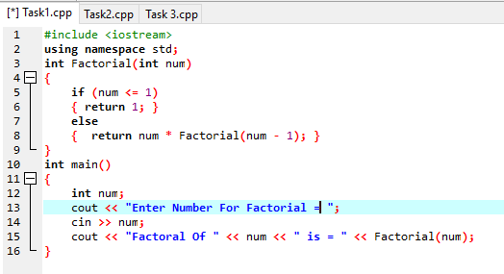

**Output:**

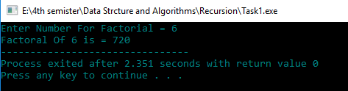

**Task No. 2:** Write a program to calculate the Fibonacci series of any given number using recursion.

**Coding:**

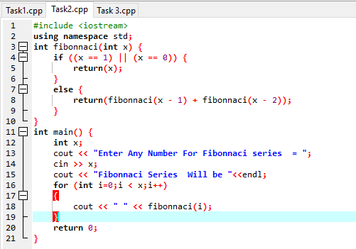

**Output:**

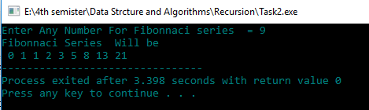

**Task No. 3:** Implementation of Tower of Hanoi problem using recursion.

**Coding:**

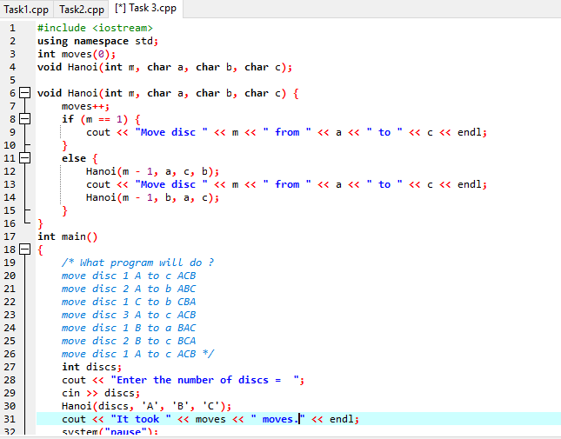

**Output:**

